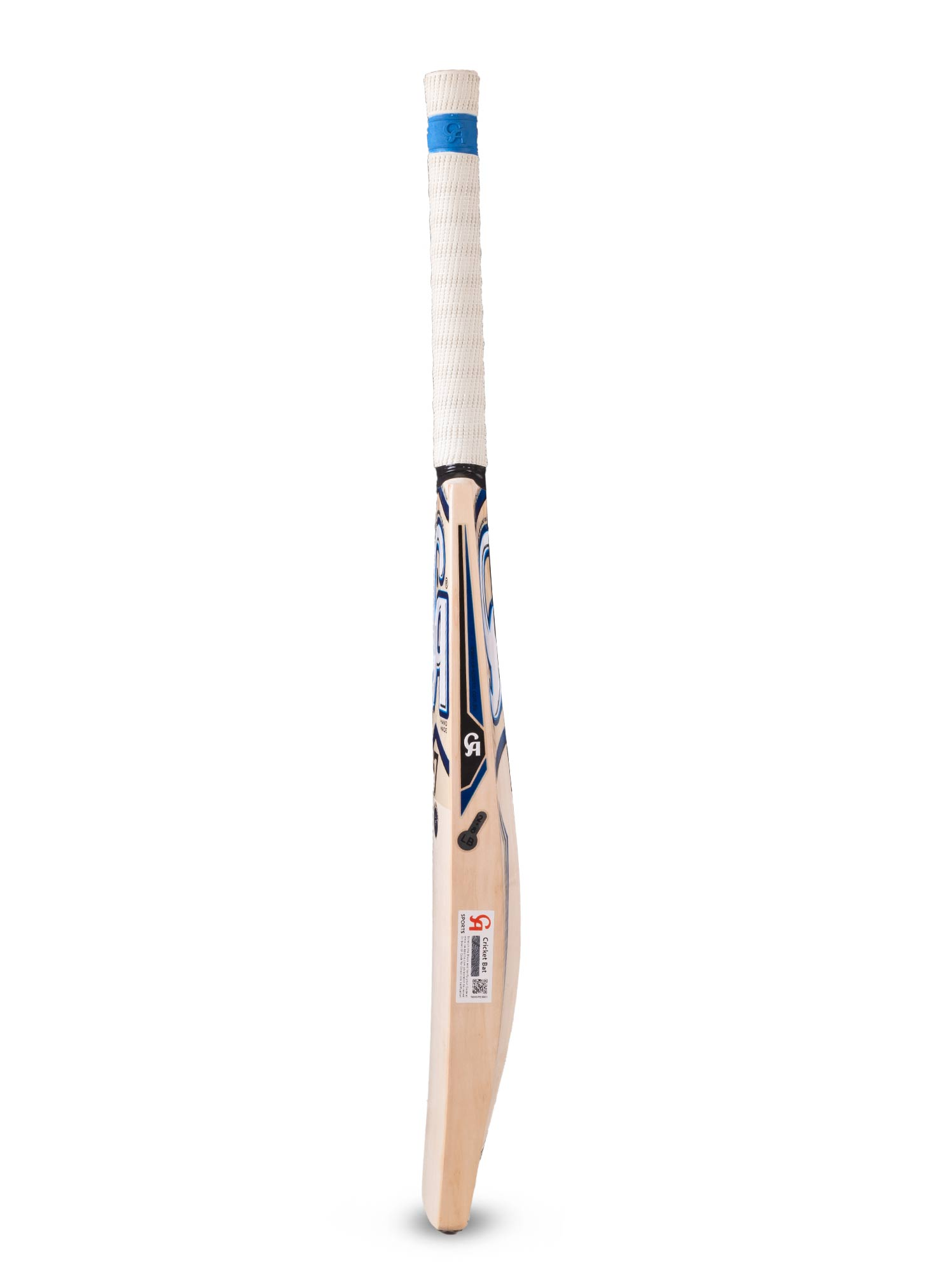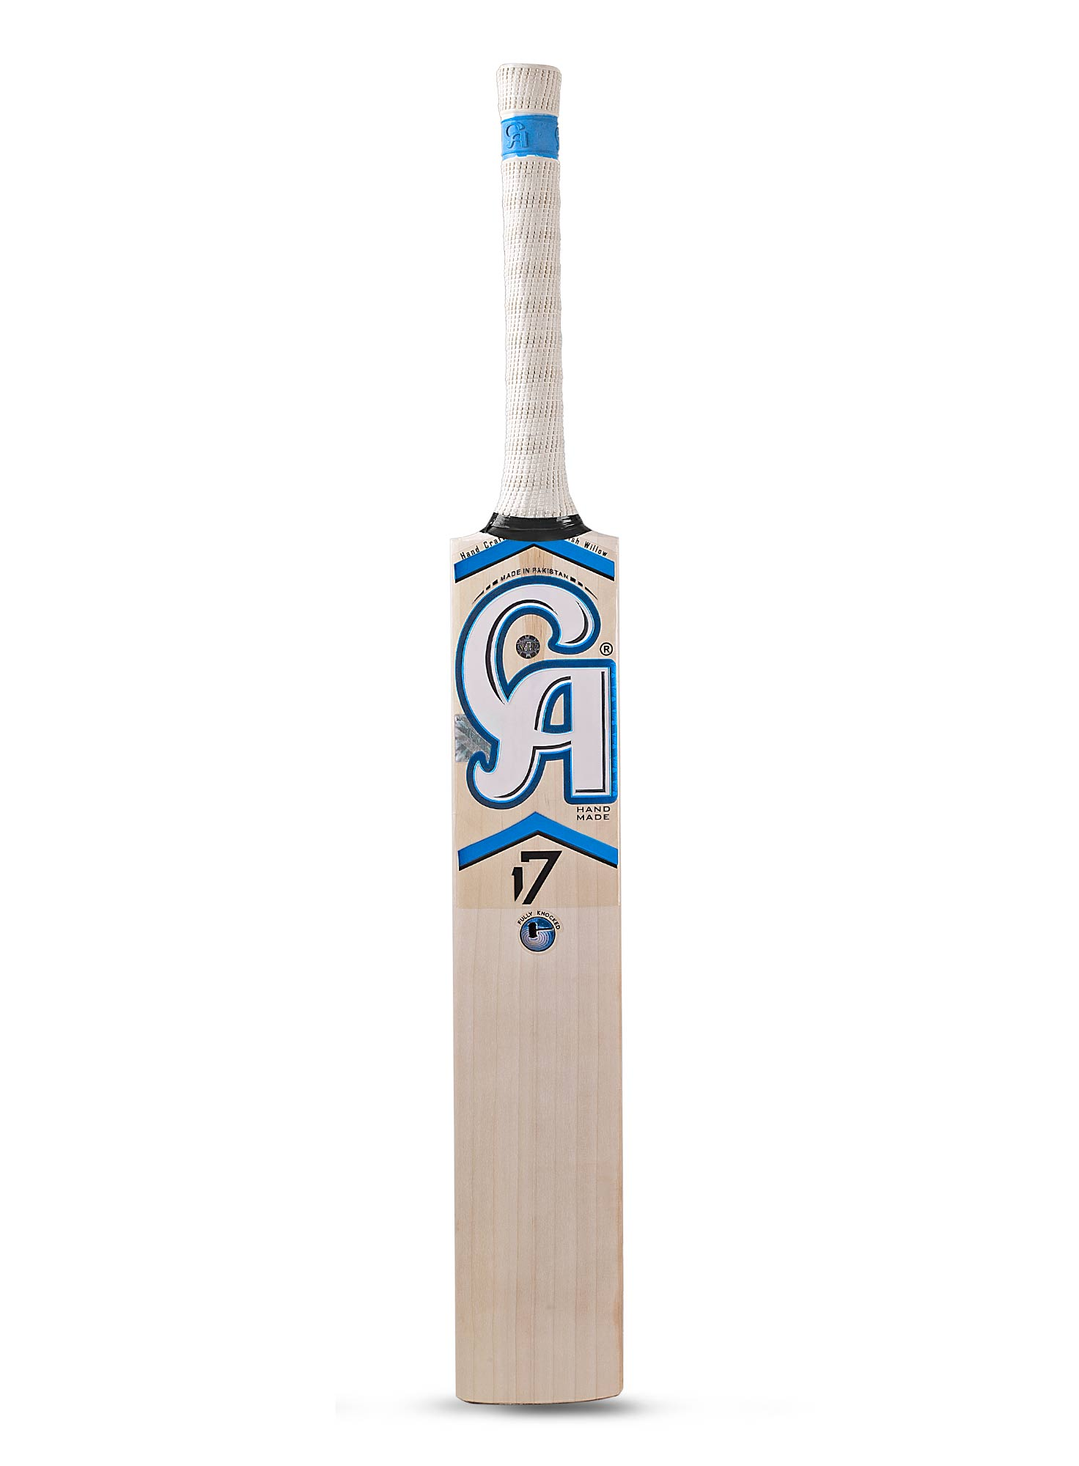

CA SPORTS EVIN LEWIS 17 BAT

Fresh looks new CA bat for those who motivate us to launch one after another with their great performances playing among CA gears. Prepared as per Evin Lewis taste, carefully planning his needs. Its' crafted from sorted 7+ grains willow.  Made for uncompromised performance maximizing players' time on crease. CA bat shaped with the fine-tuned handle grip that let you stay in performance to hit more shots effortlessly. This English willow cricket bat expertly formed edges among articulated middle will allow performers get ready to give the tough time to their rivals. Thoughtfully designed cricket bat stickers and unique complexion taking off the better feel while the toe guard express its toughness. The side barcode is for the brands' authenticity. Get the cricket bats, batting pads, cricket helmet, and thigh guards online. Adjustable bat price specified by estimating each level of players.

**DETAILS:**

* 7+ Grains English Willow bat
* Light pickup & balanced size